2D ROPE SYSTEM

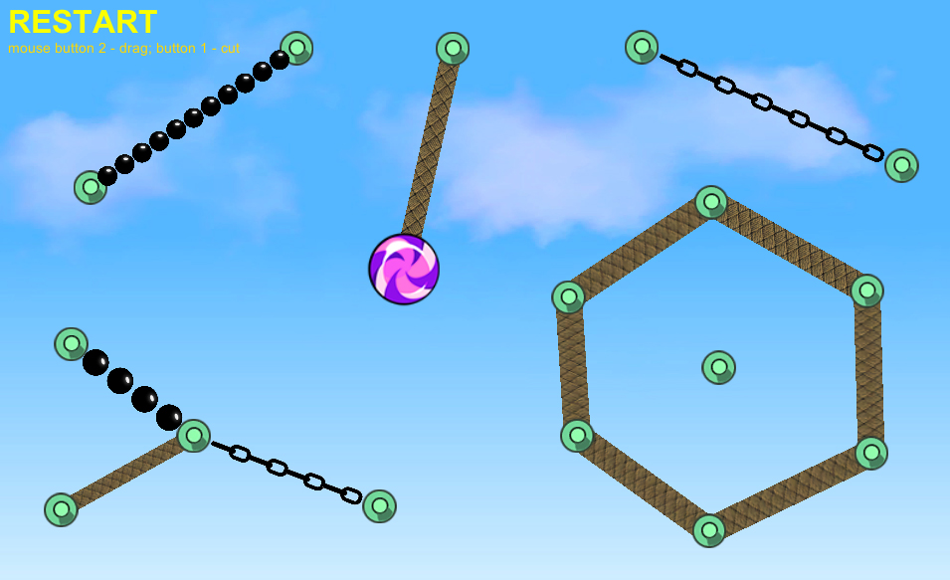

Package Description
This package contains scripts for creating any type of 2D ropes in editor and at run time.
Also contains scripts for cutting, breaking, dragging the rope, playing sound and instantiating object at break/cut position, making character climbing and swinging on rope and object pooling system.

2d rope system editor window
You call it from Window -> 2D Rope System menu.
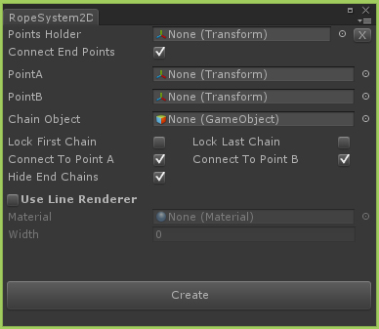

Points Holder field is for transform which are parent of all points, the rope will be created between them
X button at the end of Points Holder, clear’s its assigned value
Connect End Points checkbox determines connection between start and end points if Points Holder exists
PointA and PointB are used if Points Holder doesn’t exists, the rope will be created between them.
Chain Object is the game object which will be instantiated as chains, it must have 2D collider and 2D hinge joint attached.
Lock First Chain and Lock Last Chain determines locking first and last chain (their rigidbody2D component will be ‘isKinematic’ and physics won’t affect them)
Connect To Point A and Connect To Point B determines if PointA and PointB is connected to first and last chain
Hide End Chains determines visibility of first and last chain
Use Line Renderer determines use of line renderer component for rope, if this is enabled Chain Object’s renderer will be disabled and the rope will be rendered using line renderer component.
Material and Width is enabled when Use Line Renderer is enabled and their values are used for line renderer component.
Create button creates the rope

scripts description
There is ‘RopeSystem2D’ script in Editor folder which creates editor extension window and we have utility scripts in Scripts folder, these are:
Breakable – used for breaking chains depending on entered angle and distance values. If checkbox ‘New Mat Per Chunk’ is turned on, creates new material for broken parts to make texture scale equal to rope length, when using line renderer component for rendering rope. ‘Limit Break Count’ determines if ‘Max Break Count’ values is used to limit break count for each rope. ‘Chain Break Sound’ is played and ‘Break FX’ is instantiated at brake position.
Drag – this is attached on camera and is used to drag ragdoll with touch if “For Touch Screen” checkbox is checked or with cursor. You need to assign dragger game object, which is empty game object with Rigidbody2D and SpringJoint2D components attached.
FollowParent - Unity 4.3.1 version's 2D Rigidbody attached object doesn't follow its parent when ‘isKinematic’ is set to true, so we are arranging its transform with this script. This may won't be needed in future versions
Menu – creates 3 button for loading 3 template scenes
PlayerControl – is from unity’s 2D project and is used for 2D character movement
PoolingSystem – is used for optimization. We are using it at run-time rope creation when creating and removing rope with keys (scene 3), the rope isn’t really removed, it is deactivated/activated when needed to save memory.
Restart – restarts scene if more than 2 touch is detected for touch devices or if it is attached on guitext, restarts scene when mouse is clicked on it.
Rope2D – main heart of 2D rope system, in this script are written main functions which create the rope
RopeControl – is used for 2D character to make it able to climb and swing on rope
RopeCutter – is used to cut the rope. Is attached on game object named: ‘knife’. ‘Use touch’ checkbox determines which input to use (touch or mouse), ‘Cut sound’ is played and ‘Cut FX’ is instantiated at cut position, ‘Limit Cut Count’ determines whether use or not ‘Max Cut Count’ value to limit cut count for whole scene. ‘Limit Cut Per Object’ determines whether use or not ‘Max Cut Per Object’ value to limit cut for each rope. If checkbox ‘New Mat Per Chunk’ is turned on, creates new material for cut parts to make texture scale equal to rope length, when using line renderer component for rendering rope.
RuntimeRope – creates rope at run-time. Attached on main camera in scene 3. It has same options as editor extension, but is used to create rope at run-time.
UseLineRenderer – used to render rope with line renderer component

If you want to dive in and understand how the scripts are working, you’re more than welcome, scripts are heavily documented for you.

If you have any problems or some suggestions don't hesitate to send me to temo_koki@yahoo.com

Best regards

